27.83: a) we must subtract off the amount immersed since the bar is accelerating until it leaves the pools and thus hasn’t reached  yet.
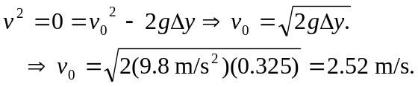

b) In a distance of 0.025 m the wire’s speed increases from zero to 2.52 m/s.
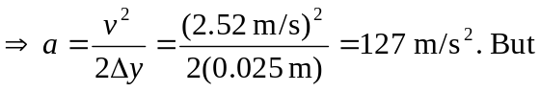
c) 